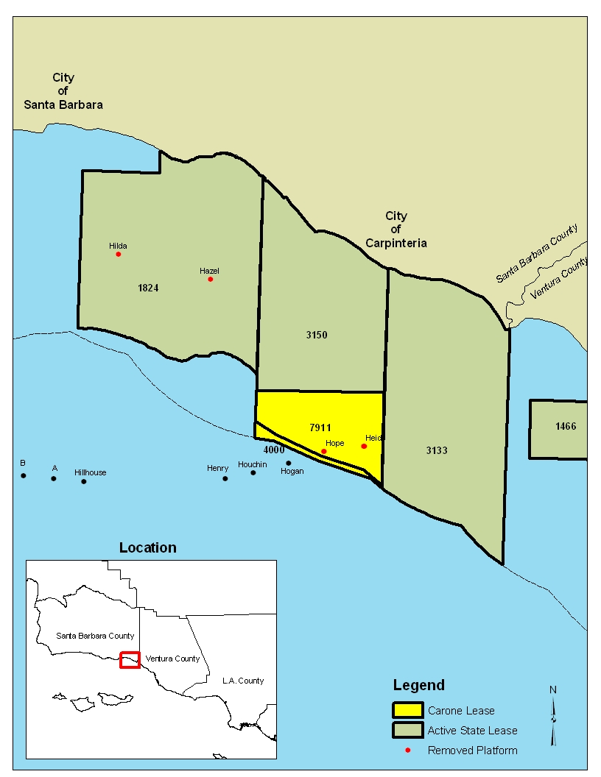

PRC 7911.1

PRC 4000.1

1 and 4000.1

**EXHIBIT B**