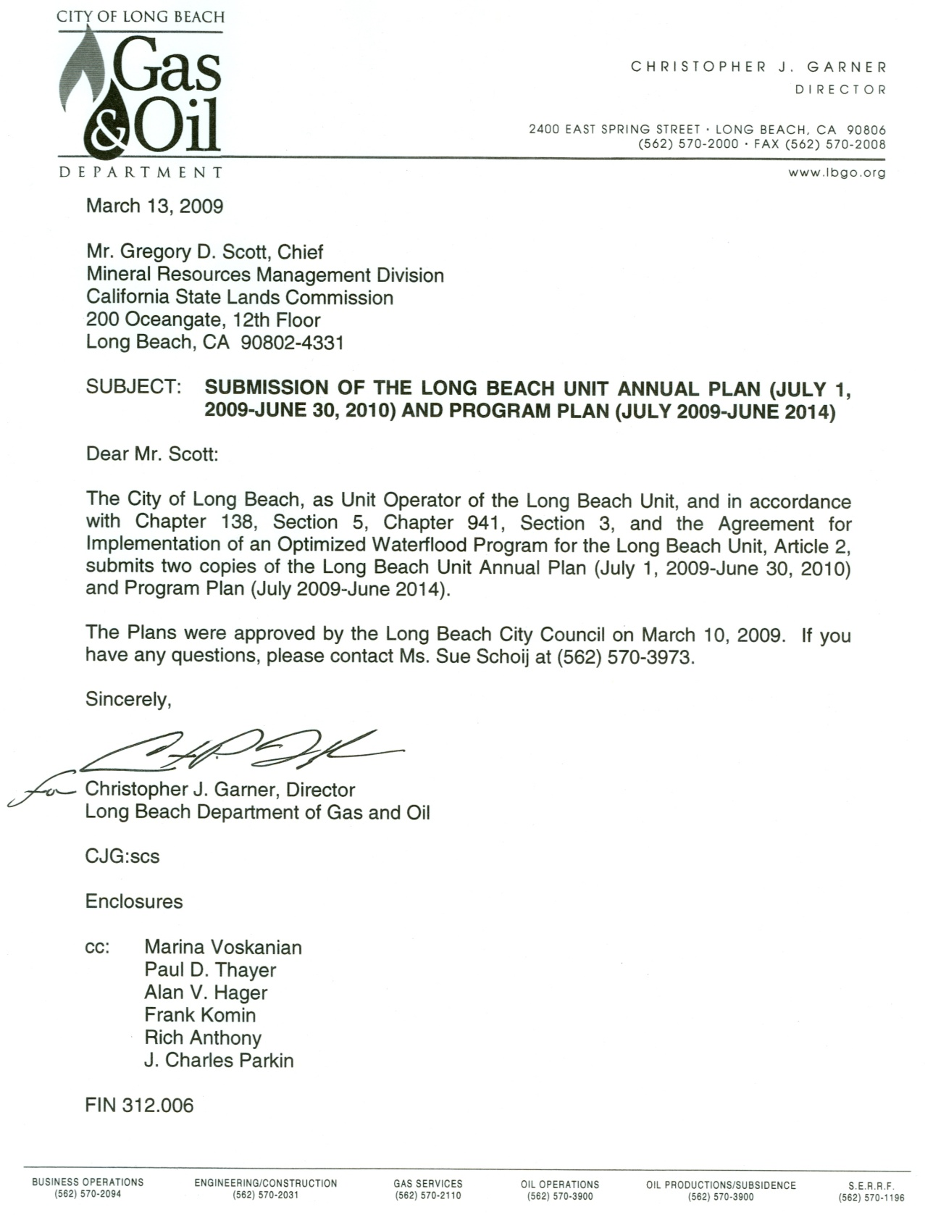

W 17163

**EXHIBIT A**